

A MINI PROJECT REPORT

on
WEB DESIGN TECHNOLOGIES (24CSE361)
STUDENT REGISTRATION FORM WITH VALIDATION

Submitted by

DOMMARAJU NIKHILESH RAJU

USN:1NH24CS067

Under the guidance of

Ms. M. THANGA SUBHA DEVI
Sr. Assistant Professor
In partial fulfillment for the award of the degree of

BACHELOR OF ENGINEERING
in
COMPUTER SCIENCE AND ENGINEERING
Academic Year: 2025-26 (ODD SEM)



CERTIFICATE

This is to certify that the mini project work titled “Student Registration form with Validation” is a bonafide work carried out by DOMMARAJU NIKHILESH RAJU (1NH24CS067) in partial fulfillment of the degree of Bachelor of Engineering in Computer Science and Engineering of the New Horizon College of Engineering during the year 2025-2026.

Signature of Guide Signature of HOD

SEMESTER END EXAMINATION

Name of the Examiner Signature with date

1.

2.

ABSTRACT

The Student Registration Form is an interactive web-based application developed using HTML, CSS, and JavaScript with the purpose of providing students with instant, visually structured learning paths across various technology domains. With the rising demand for skills in fields such as Web Development, Machine Learning, Artificial Intelligence, DevOps, Cybersecurity, and Blockchain, learners frequently struggle to identify a clear, step-by-step sequence of topics they must master. This project solves that challenge by generating a professional, animated, and user-friendly registration details based on the student selected career path.

The application features a responsive layout, modern UI components, a vertical animated timeline, aesthetic gradient backgrounds, and dynamic DOM manipulation. The user interface is driven by HTML and CSS, while the entire registerd data is stored in structured JavaScript objects. When a user selects a career path, a detailed timeline consisting of milestones, steps, and durations is dynamically displayed with smooth animations.

project demonstrates sound knowledge of frontend development, UI/UX principles, JavaScript This data structures, event-driven programming, DOM manipulation, and responsive design. It can serve as an educational tool for students, beginners, and self-learners entering the world of technology.

ACKNOWLEDGEMENT
The satisfaction and euphoria that accompany the successful completion of any task would be impossible without the mention of the people who made it possible, who’s constant guidance and encouragement crowned our efforts with success.

I have great pleasure in expressing gratitude to Dr. Mohan Manghnani, Chairman, New Horizon Educational Institutions, for providing necessary infrastructure and creating good environment.

I take this opportunity to express my profound gratitude to Dr. Manjunatha, Principal, New Horizon College of Engineering, for the constant support and encouragement.

I would like to thank Dr. Anandhi R J, Professor and Dean-Academics, NHCE, for her valuable guidance.

I would also like to thank Dr. B. Rajalakshmi, Professor and HOD, Department of Computer Science and Engineering, for the constant support.

I also express my gratitude to Ms M. Thanga Subha Devi, Sr.Assistant Professor, Department of Computer Science and Engineering, my mini project reviewer, for constantly monitoring the development of the project and setting up precise deadlines. Her valuable suggestions were the motivating factors in completing the work.

D.NIKHILESH RAJU

USN:1NH24CS067

CONTENTS
ABSTRACT | I
ACKNOWLEDGEMENT | II
CONTENTS | III
LIST OF FIGURES | V
- INTRODUCTION | 1
1.1 PROBLEM DEFINITION | 1
- OBJECTIVES | 2
1.3 METHODOLOGIES TO BE FOLLOWED | 3
- FUNDAMENTALS OF THE LANGUAGES USED | 4
2.1 HTML | 6
2.2 HTML TAGS | 6
2.3 CSS | 8,9
2.4 JAVASCRIPTS | 10
- REQUIREMENT SPECIFICATION | 10
3.1 HARDWARE REQUIREMENTS | 10
3.2 SOFTWARE REQUIREMENTS | 10
- DESIGN | 11
4.1 DESIGN GOALS | 11
- IMPLEMENTATION | 12
5.1 USER INTERFACE | 12
5.2 CSS EXPLANATION | 14

5.3  5.4  5.5  5.6 | JAVASCRIPT VALIDATION LOGIC  STORING STUDENT DETAILS  DISPLAYING STUDENTS  EDIT & DELETE FUNCTIONS | 16  17  20  21
- RESULTS
6.1 | OUTPUT SCREENS | 22,23
- CONCLUSION |  | 24
REFERENCES

LIST OF FIGURES

Figure No. | Description | Page No.
5.1.1 | Home Page | 12
5.1.2 | Registration Form | 14
5.1.3 | Validation Error  Messages | 15
5.1.4 | Stored Student List | 15
5.1.5 | View Student Popup | 16
5.1.6 | Edit Student Popup | 16
5.4.3 | app.js - & renderView | 17
5.4.4 | app.js - generatepdf | 17
5.4.5 | app.js - renderSavedpdf | 18
5.4.6 | app.js – Registration Detail & togglePhaseCompletion | 18
5.5.1 | Registration Data.js - getRegistrationData | 19
5.6.1 | styles.css - Timeline & Phase Card | 20
5.6.2 | Helper Functions | 20

LIST OF TABLES

Table No. | Description | Page No.
2.2.1 | HTML Tags | 5
2.2.2 | CSS Tags | 6,7

CHAPTER 1

INTRODUCTION

The rapid growth of digital systems has increased the need for efficient and automated solutions in educational institutions. One of the most essential components in any academic environment is maintaining accurate student records. Traditionally, student registration was performed manually using paper forms, which led to issues such as misplaced data, human errors, slow processing, and difficulty in retrieving information.

A Student Registration Form with Validation provides an efficient, user-friendly, and reliable solution for handling student data. Using modern web technologies such as HTML, CSS, and JavaScript, this system allows users to enter student details through an interactive interface while ensuring that the entered information follows specific rules and formats.

This system stores the data locally and displays it in a structured table, allowing easy access, updates, and deletion of records. The application demonstrates fundamental front-end development concepts and adheres to principles of responsive design, form validation, and user experience.

  - Problem Definition
l institutions face several challenges when collecting and maintaining student information using traditional methods. The major problems include:
1. Human Errors
Educationa
Incorrect or invalid data entry due to lack of validation.

2. Manual Workload
Teachers or administrative staff must manually read, verify, and record data.

3. Data Misplacement
Physical forms can be damaged, lost, or become illegible over time.

4. Slow Retrieval
Searching for specific student details becomes time-consuming

5. Lack of Consistency
Without standardized validation, formats may differ for phone numbers, emails, names, etc.

The Student Registration Form with Validation aims to solve these problems using client-side validation and structured storage.

1.3 METHODOLOGIES TO BE FOLLOWED

The methodology followed for the development of the project:

1. Requirement Analysis

Understanding the required data fields and validation rules:

Name patterns

Email format

Phone number formatting

Mandatory fields

Photo uploading

Supporting documents

2. UI/UX Designing

Buttons

Table layout

Modal popups

3. HTML Structure Creation

Building the full user interface:

Form elements

Input fields
Dropdown menu
Buttons
Table for student data

4. CSS Styling

Applying:

Color themes

Layout grids

Spacing

Buttons

Responsive design

5. JavaScript Logic Development

Implementing:

Form validation

Error messages

Storing student data in localStorage

Rendering student list

Editing and deleting entries

Modal functions

6. Testing

Testing for:

Correct validation

Proper rendering of the list

Mobile responsiveness

CHAPTER 2

FUNDAMENTALS OF THE LANGUAGES USED

HTML

HTML (HyperText Markup Language) is the standard language used to create the structure of web pages. It defines the layout using elements such as headings, forms, inputs, tables, buttons, and containers.

In this project, HTML is used to:

Create the student registration form

Organize input fields (textboxes, dropdowns, radio buttons)

Display student information in a table

Define modal/pop-up structures

Create responsive card layouts and sections

Add file upload fields for photos and documents

HTML TAGS

HTML Tag | Purpose / Function in This Project
<!DOCTYPE html> | Declares HTML5 document type.
<html> | Root element of the entire webpage.
<head> | Holds metadata, stylesheet link, title, viewport settings.
<meta> | Provides character encoding and responsive scaling for all devices.
<title> | Sets the title “Student registration form” in browser tab.
<link> | Links the external CSS file styles.css.
<body> | Contains all visible UI components (sidebar, header, modal, main views).
<div> | Most heavily used container element for layout (sidebar, cards, sections, modal).
<canvas> | Used for animated particle background in the app.
<nav> | Contains navigation buttons in the sidebar (Dashboard, Generator, Saved).
<button> | Used for registration, opening modal, generating details , marking phases completed.
<span> | Used for icons, labels, and inline text formatting.
<svg> | Used to display vector icons inside sidebar buttons and UI.
<header> | Top bar containing user profile icon.
<main> | The main content area where views (dashboard, generator, saved) are dynamically rendered.
<h1>, <h2>, <h3> | Headings used in modal, student registration details, and cards.
<p> | For descriptions, subtitles, registration details.
<label> | For modal form labels (“Select Tech Field”, “Difficulty Level”).
<select> | Dropdown control for field selection and difficulty selection.
<option> | Selectable items inside dropdown (Beginner, Intermediate, Advanced, fields list).
<script> | Loads external JavaScript files: studentData.js and app.js.

2.3 CSS

CSS styles the entire interface. It handles:

- background gradients
- card design
- timeline animation
- hover effects
- responsive behavior
- layout spacing
- shadows and borders
Key CSS Concepts Used
- linear-gradient() for modern backgrounds
- box-shadow for 3D look
- border-radius for softer UI
- flexbox layout
- @media queries to make it mobile-friendly
- custom animations using @keyframes fadeInUp
- hover transitions with transition: all 0.3s

CSS Selector / Property | Purpose / Function in This Project
* | Universal selector used for setting global margin, padding, box-sizing.
:root | Stores theme variables like colors, spacing, text colors for easy reuse.
body | Sets global background, font smoothing, dark/light mode settings.
.sidebar | Creates the left navigation pane with fixed height and full-screen layout.
.nav-btn | Styles sidebar buttons with padding, hover effect, active state.
.main-content | Controls layout area where all pages are dynamically rendered.
.header | Styles top bar with shadow, padding, background color.
.modal-overlay | Darkened transparent overlay for popup modal.
.modal-content | Styled card for roadmap generator input (rounded corners, padding).
.modal-select | Custom-styled dropdown for selecting fields and difficulty.
.generate-btn | Styled “Generate Student Registration form” button with gradients and hover transitions.
.details-card | Card layout used to display saved details and summary items.
.phase-card | Card displaying each phase inside student details (topics, skills, tools).
.topic-card | Styled block for each topic inside a phase.
.skill-tag | Small badge showing skills required for the phase.
.tool-tag | Badge showing tools used in a topic.
.timeline | Vertical timeline structure for connecting registration topics.
.timeline::before | Pseudo-element drawing the vertical colored timeline line.
.btn | Shared button style (radius, padding, transition).
.btn-primary | Colored gradient button variant.
.btn-secondary | Neutral grey/white button variant.
.dark-mode | Overrides for dark UI theme.
@media (max-width: 768px) | Mobile responsiveness for smaller devices.
display: flex | Used widely for aligning items horizontally (header, cards, sidebar).
display: grid | Used for dashboard grid stats and saved details grid view.
border-radius | Used for rounded edges across cards and buttons.
box-shadow | Used for elevated UI card effect.
transition | Smooth hover animations for buttons, cards.
padding / margin | Used throughout for consistent spacing.
background: linear-gradient() | Used on buttons and timeline for modern look.

JAVASCRIPT

JavaScript provides logic and interactivity.
Main JavaScript Tasks
- Storing students data (career paths + steps)
- Detecting user-selected path
- Generating HTML dynamically for each timeline item
- Animating timeline items
- Resetting view to original form
Programming Concepts Used
- Objects and arrays
- DOM manipulation
- addEventListener() events
- loops (forEach)
- dynamic HTML injection
- animations triggers

CHAPTER 3

REQUIREMENT SPECIFICATION

HARDWARE REQUIREMENTS

• Any PC/Laptop with minimum 4GB RAM
• Processor: Dual Core or higher
• Display: 1024×768 resolution
• Keyboard & mouse or touch input

SOFTWARE REQUIREMENTS

• HTML5
• CSS3
• JavaScript ES6
• Browser (Chrome / Firefox / Edge)
• Text editor (VS Code recommended)

CHAPTER 4
DESIGN

4.1 DESIGN GOALS

- Clean Minimal UI
Simple layout with enough spacing and proper alignment.

- Aesthetic Visual Design
Gradient backgrounds, rounded cards, vibrant colors.
- Engagement
Smooth animations for timeline items, hover effects.
- Scalability
New career paths can be added easily by updating JavaScript data.
- Responsiveness
Works well on desktop, tablet, and mobile.

CHAPTER 5

IMPLEMENTATION

<!DOCTYPE html>
<html lang="en">
<head>
<meta charset="UTF-8">
<meta name="viewport" content="width=device-width, initial-scale=1.0">
<title>Techform – Student registration Form</title>
<link rel="stylesheet" href="styles.css">
</head>
<body>
<div id="app" class="min-h-screen">
<!-- Animated Background Canvas -->
<canvas id="animatedCanvas" class="fixed inset-0 pointer-events-none z-0"></canvas>
<!-- Sidebar -->
<div id="sidebar" class="sidebar">
<!-- Logo -->
<div class="p-6 flex items-center gap-3">
<div class="logo-icon">
<svg class="icon-map" viewBox="0 0 24 24" fill="none" stroke="currentColor" stroke-width="2">
<polygon points="1 6 1 22 8 18 16 22 23 18 23 2 16 6 8 2 1 6"></polygon>
<line x1="8" y1="2" x2="8" y2="18"></line>
<line x1="16" y1="6" x2="16" y2="22"></line>
</svg>
</div>
<span class="logo-text">Techform</span>
</div>
<!-- Navigation -->
<nav class="flex-1 px-3">
<button class="nav-btn active" data-view="dashboard">
<svg class="w-5 h-5" viewBox="0 0 24 24" fill="none" stroke="currentColor" stroke-width="2">
<path d="M3 9l9-7 9 7v11a2 2 0 0 1-2 2H5a2 2 0 0 1-2-2z"></path>
<polyline points="9 22 9 12 15 12 15 22"></polyline>
</svg>
<span>Dashboard</span>
</button>
<button class="nav-btn" data-view="generator">
<svg class="w-5 h-5" viewBox="0 0 24 24" fill="none" stroke="currentColor" stroke-width="2">
<polygon points="1 6 1 22 8 18 16 22 23 18 23 2 16 6 8 2 1 6"></polygon>
<line x1="8" y1="2" x2="8" y2="18"></line>
<line x1="16" y1="6" x2="16" y2="22"></line>
</svg>
<span>Student registration form</span>
</button>
<button class="nav-btn" data-view="saved">
<svg class="w-5 h-5" viewBox="0 0 24 24" fill="none" stroke="currentColor" stroke-width="2">
<path d="M19 21l-7-5-7 5V5a2 2 0 0 1 2-2h10a2 2 0 0 1 2 2z"></path>
<polyline points="9 10 12 13 16 9"></polyline>
</svg>
<span>Saved student details</span>
</button>
</nav>
<!-- Footer -->
<div class="p-6 border-t footer-border">
<p class="footer-text">© 2024 Techform</p>
<p class="footer-version">Version 1.0.0</p>
</div>
</div>
<!-- Main Content -->
<div class="main-content">
<!-- Header -->
<header class="header">
<div class="flex-1"></div>
<div class="flex items-center gap-3">
<button class="user-btn">
<svg class="w-5 h-5" viewBox="0 0 24 24" fill="none" stroke="currentColor" stroke-width="2">
<path d="M20 21v-2a4 4 0 0 0-4-4H8a4 4 0 0 0-4 4v2"></path>
<circle cx="12" cy="7" r="4"></circle>
</svg>
</button>
</div>
</header>
<!-- Content Area -->
<main class="p-8" id="contentArea">
<!-- Content will be dynamically inserted here -->
</main>
</div>
</div>
<!-- Modal -->
<div id="modal" class="modal-overlay hidden">
<div class="modal-content">
<div class="flex items-start gap-4 mb-6">
<div class="modal-icon">
<svg class="w-6 h-6 text-white" viewBox="0 0 24 24" fill="none" stroke="currentColor" stroke-width="2">
<path d="m12 3-1.912 5.813a2 2 0 0 1-1.275 1.275L3 12l5.813 1.912a2 2 0 0 1 1.275 1.275L12 21l1.912-5.813a2 2 0 0 1 1.275-1.275L21 12l-5.813-1.912a2 2 0 0 1-1.275-1.275L12 3Z"></path>
<path d="M5 3v4M3 5h4M6 17v4M4 19h4"></path>
</svg>
</div>
<div class="flex-1">
<h2 class="modal-title">Generate Student details</h2>
<p class="modal-subtitle">Create your personalized learning path</p>
</div>
<button id="closeModal" class="close-btn">
<svg class="w-5 h-5" viewBox="0 0 24 24" fill="none" stroke="currentColor" stroke-width="2">
<line x1="18" y1="6" x2="6" y2="18"></line>
<line x1="6" y1="6" x2="18" y2="18"></line>
</svg>
</button>
</div>
<div class="space-y-4">
<div>
<label class="modal-label">Select Tech Field</label>
<select id="fieldSelect" class="modal-select">
<option value="">Choose a field...</option>
</select>
</div>
<div>
<label class="modal-label">Difficulty Level</label>
<select id="difficultySelect" class="modal-select">
<option value="">Choose difficulty...</option>
<option value="Beginner">Beginner</option>
<option value="Intermediate">Intermediate</option>
<option value="Advanced">Advanced</option>
</select>
</div>
<button id="generateBtn" class="generate-btn" disabled>
<svg class="w-5 h-5" viewBox="0 0 24 24" fill="none" stroke="currentColor" stroke-width="2">
<path d="m12 3-1.912 5.813a2 2 0 0 1-1.275 1.275L3 12l5.813 1.912a2 2 0 0 1 1.275 1.275L12 21l1.912-5.813a2 2 0 0 1 1.275-1.275L21 12l-5.813-1.912a2 2 0 0 1-1.275-1.275L12 3Z"></path>
<path d="M5 3v4M3 5h4M6 17v4M4 19h4"></path>
</svg>
Generate Student details
</button>
</div>
</div>
</div>
<script src="student Data.js"></script>
<script src="app.js"></script>
</body>
</html>

This snapshot shows the complete HTML page (index.html). It contains the canvas for the animated background, the fixed sidebar, the header, the main content container (#contentArea) where views are dynamically rendered, and the modal used to collect user input for generating details. Scripts are loaded at the end (studentData.js and app.js).

5.2.2 Sidebar & details (Snapshot)
<div id="sidebar" class="sidebar">
<div class="p-6 flex items-center gap-3">
<div class="logo-icon">...</div>
<span class="logo-text">Techform</span>
</div>
<nav class="flex-1 px-3">
<button class="nav-btn active" data-view="dashboard">Dashboard</button>
<button class="nav-btn" data-view="generator">student registration form</button>
<button class="nav-btn" data-view="saved">Saved student details</button>
</nav>
<div class="p-6 border-t footer-border">© 2024 Techform</div>
</div>

The sidebar provides persistent navigation across the app. `nav-btn` elements include a data-view attribute; clicking them triggers navigation handled by JavaScript (navigateTo). The footer contains branding and versioning.

5.2.3 Generator Modal (Snapshot)
<div id="modal" class="modal-overlay hidden">
<div class="modal-content">
<div class="flex items-start gap-4 mb-6">
<div class="modal-icon">...</div>
<div class="flex-1">
<h2 class="modal-title">Generate details</h2>
<p class="modal-subtitle">Create your personalized learning path</p>
</div>
<button id="closeModal" class="close-btn">...</button>
</div>
<div class="space-y-4">
<label class="modal-label">Select Tech Field</label>
<select id="fieldSelect" class="modal-select"></select>
<label class="modal-label">Difficulty Level</label>
<select id="difficultySelect" class="modal-select"></select>
<button id="generateBtn" class="generate-btn" disabled>Generate students details</button>
</div>
</div>
</div>

The modal is the input form for creating a new details. JavaScript populates the field dropdown from student Data.js, validates inputs, and enables the Generate button when valid selections are made.

5.3.1 styles.css Key Excerpts (Snapshot)
:root {
--bg-primary: #f9fafb;
--purple-600: #9333ea;
--border-color: #e5e7eb;
--text-primary: #111827;
}
/* Sidebar */
.sidebar {
position: fixed;
left: 0;
top: 0;
height: 100vh;
width: 16rem;
background-color: var(--bg-secondary);
border-right: 1px solid var(--border-color);
display: flex;
flex-direction: column;
}
/* Header */
.header {
background-color: var(--bg-secondary);
border-bottom: 1px solid var(--border-color);
padding: 1rem 2rem;
}
/* Modal styles (excerpt) */
.modal-overlay { position: fixed; inset: 0; background: rgba(0,0,0,0.5); display:flex; align-items:center; justify-content:center; }
.modal-content { background: var(--bg-secondary); border-radius: 1rem; padding: 1.5rem; max-width: 28rem; width:100%; }
/* Roadmap card */
.roadmap-card { background-color: var(--bg-secondary); border-radius: 0.75rem; padding: 1.5rem; border: 1px solid var(--border-color); }

This CSS snapshot highlights the theme variables, sidebar layout, header, modal overlay, and details-card styling. The project uses CSS variables for easy theming and a utility-first style for reusable classes.

5.4.1 app.js - Initialization (Snapshot)
// App State
let state = {
currentView: 'dashboard',
darkMode: true,
details: [],
selectedstudent: null,
completedPhases: {}
};
document.addEventListener('DOMContentLoaded', () => {
initializeApp();
});
function initializeApp() {
setupEventListeners();
populateFieldSelect();
setupAnimatedBackground();
document.body.classList.add('dark-mode');
renderView();
}

This snippet initializes the application state, sets up event listeners, populates the field select dropdown from roadmapData, starts the animated background, applies dark mode, and renders the initial view.

5.4.2 app.js - Animated Background (Snapshot)
function setupAnimatedBackground() {
const canvas = document.getElementById('animatedCanvas');
const ctx = canvas.getContext('2d');
canvas.width = window.innerWidth;
canvas.height = window.innerHeight;
const particles = [];
const particleCount = 50;
for (let i=0;i<particleCount;i++){
particles.push({x:Math.random()*canvas.width, y:Math.random()*canvas.height, size:Math.random()*3+1, speedX:(Math.random()-0.5)*0.5, speedY:(Math.random()-0.5)*0.5, opacity:Math.random()*0.5+0.2});
}
function animate(){ /* draws particles and connections, then requestAnimationFrame(animate) */ }
animate();
}

The animated background uses a canvas with lightweight particle rendering and line connections for a subtle motion effect. It adapts on window resize.

5.4.3 app.js – Student & details(Snapshot)
function studentTo(view) {
state.currentView = view;
document.querySelectorAll('.nav-btn').forEach(btn => {
btn.classList.toggle('active', btn.dataset.view === view);
});
renderView();
}
function renderView() {
const contentArea = document.getElementById('contentArea');
switch (state.currentView) {
case 'dashboard':
renderDashboard(contentArea);
break;
case 'generator':
renderGenerator(contentArea);
break;
case 'saved':
renderSavedRoadmaps(contentArea);
break;
case 'roadmap-detail':
renderRoadmapDetail(contentArea);
break;
}
}
function renderDashboard(container) {
const totalRoadmaps = state.roadmaps.length;
const completedNodes = state.roadmaps.reduce((sum, r) => sum + r.completedNodes, 0);
const totalHours = state.roadmaps.reduce((sum, r) => sum + r.learningHours, 0);
container.innerHTML = `...dashboard HTML...`;
}

Navigation updates state.currentView and toggles active classes. renderView dispatches to view-specific renderers. renderDashboard computes basic stats (roadmaps, completed nodes, total hours) and injects dashboard HTML.

5.4.4 app.js – generatestudentdata (Snapshot)
function generatestudentdata() {
const field = document.getElementById('fieldSelect').value;
const difficulty = document.getElementById('difficultySelect').value;
if (!field || !difficulty) return;
const newstudent = {
id: Date.now().toString(),
field,
difficulty,
createdAt: new Date(),
nodes: getstudentData(field, difficulty).phases.map(p => p.title),
completedNodes: 0,
learningHours: 0,
detailedstudent: getstudentData(field, difficulty)
};
state.student.push(newdetails);
closeModal();
navigateTo('saved');
}

Generatestudent details creates a new details object using getstudentData from studentData.js, pushes it to student details, closes the modal, and navigates to the saved student details view.

5.4.5 app.js – renderSavedstudent details(Snapshot)
function renderSavedRoadmaps(container) {
if (state.roadmaps.length === 0) {
container.innerHTML = `...empty state...`;
return;
}
const roadmapsHTML = state.roadmaps.map(roadmap => {
const progressPercent = (roadmap.completedNodes / roadmap.nodes.length) * 100;
return `
<div class="roadmap-card" onclick="viewRoadmapDetail('${roadmap.id}')">
<h3 class="roadmap-title">${roadmap.field}</h3>
<div>Phases: ${roadmap.completedNodes}/${roadmap.nodes.length}</div>
<div>Duration: ${roadmap.detailedRoadmap.totalDuration}</div>
</div>
`;
}).join('');
container.innerHTML = `<div class="grid ...">${roadmapsHTML}</div>`;
}

This function renders a card for each saved details, showing progress, duration, and enabling click-to-view details via viewstudent Detail.

5.4.6 app.js - renderstudentDetail & togglePhaseCompletion (Snapshot)
function renderstudentDetail(container) {
if (!state.selecteddetail) return;
const detail= state.selectedstudent;
const phasesHTML = student.detaileddata.phases.form((phase, index) => {
const isCompleted = isPhaseCompleted(detail.id, phase.id);
return `
<div class="phase-card">
<div class="phase-header">
<h3 class="phase-title">${phase.title}</h3>
<button onclick="togglePhaseCompletion('${roadmap.id}', '${phase.id}')" class="btn">${isCompleted ? '✓ Completed' : 'Mark Complete'}</button>
</div>
<div>${phase.topics.map(t => `<div class="topic-card"><h5>${t.name}</h5></div>`).join('')}</div>
</div>
`;
}).join('');
container.innerHTML = `<div>${phasesHTML}</div>`;
}
function togglePhaseCompletion(roadmapId, phaseId) {
const key = `${roadmapId}-${phaseId}`;
const current = state.completedPhases[key] || [];
if (current.length > 0) {
state.completedPhases[key] = [];
// update counts...
} else {
state.completedPhases[key] = ['done'];
// update counts...
}
renderView();
}

renderstudenrDetail builds the roadmap detail UI with phase cards, topics, skills, tools, and projects. togglePhaseCompletion toggles per-phase completion state and triggers UI refresh.

5.5.1 studentData.js - getstudentdata (Snapshot)
// student Data - Converted from TypeScript
const getstudentData = (field, difficulty) => {
const details= {
'Frontend Development': {
'Beginner': {
field: 'Frontend Development',
difficulty: 'Beginner',
overview: 'Learn the fundamentals of web development and create interactive, responsive websites.',
totalDuration: '4-6 months',
phases: [
{
id: '1',
title: 'Web Fundamentals',
duration: '6-8 weeks',
topics: [
{
name: 'HTML Basics',
subtopics: ['HTML structure', 'Semantic HTML', 'Forms and inputs', 'Media elements', 'Accessibility basics']
},
{
name: 'CSS Fundamentals',
subtopics: ['Selectors and specificity', 'Box model', 'Colors and typography', 'Positioning', 'Display properties']
},
{
name: 'Responsive Design',
subtopics: ['Flexbox', 'CSS Grid', 'Media queries', 'Mobile-first approach', 'Viewport units']
}
],
skills: ['HTML5', 'CSS3', 'Responsive Design', 'Web Accessi
/* ...rest of data omitted for brevity... */

The getstudengtData function returns structured details objects keyed by field and difficulty. Each student contains overview, totalDuration, and an array of phases. Each phase contains id, title, duration, topics (with subtopics), skills, tools, and projects.

5.6.1 styles.css - Timeline & Phase Card (Snapshot)
.timeline {
position: relative;
padding-left: 50px;
}
.timeline::before {
content: '';
position: absolute;
left: 20px;
top: 0;
bottom: 0;
width: 4px;
background: linear-gradient(180deg, var(--purple-600) 0%, #764ba2 100%);
}
.phase-card { padding: 1.5rem; border:1px solid var(--border-color); border-radius: 0.75rem; background: var(--bg-secondary); }

Timeline pseudo-element draws the vertical line. Phase-card styling defines padding, border, background, and radius to visually separate details phases.

5.6.2 Helper Functions (Snapshot)
function viewstudentDetail(studentId) {
const student = state.student.find(r => r.id === studentId);
if (student) {
state.selectedstudent = student;
state.currentView = 'student-detail';
renderView();
}
}
function populateFieldSelect() {
const select = document.getElementById('fieldSelect');
techFields.forEach(field => {
const option = document.createElement('option');
option.value = field;
option.textContent = field;
select.appendChild(option);
});
}

CHAPTER 6

RESULTS

The Student Registration Form with Validation was successfully developed and tested. The system performs all essential tasks smoothly, including form validation, data storage, table rendering, editing, deleting, filtering, and exporting.

This chapter includes the output screens
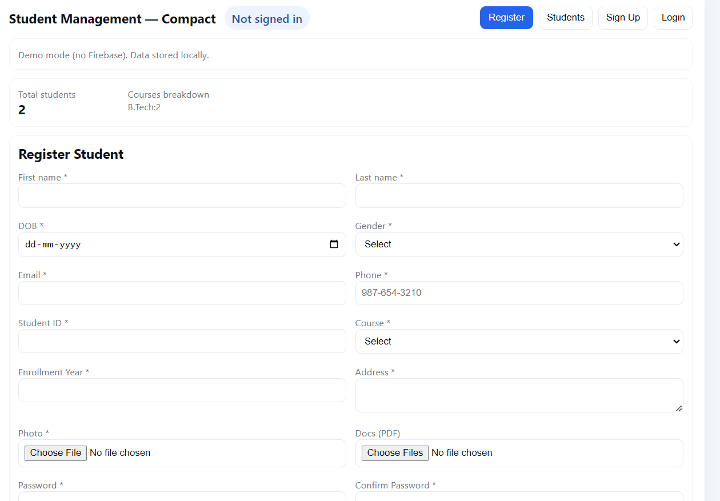

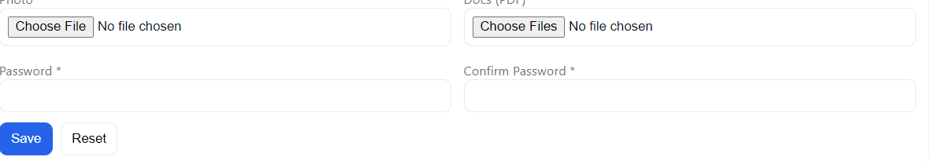

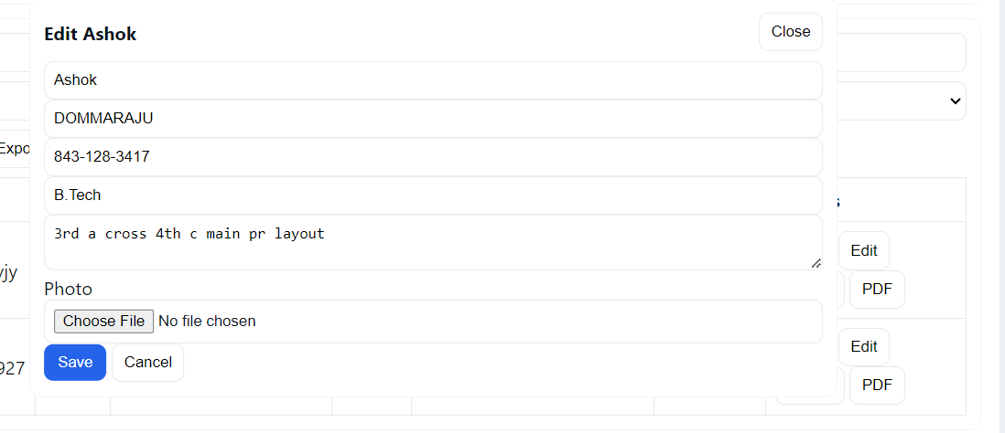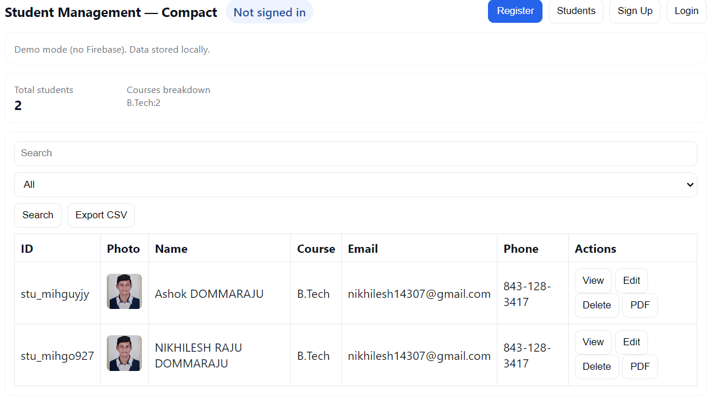
CHAPTER 7

CONCLUSION

The Student Registration Form with Validation project successfully demonstrates the use of modern web development technologies to build a functional, user-friendly application. The system allows users to input student details efficiently while ensuring accuracy through real-time validation. JavaScript plays a crucial role in enforcing proper input formats, preventing invalid submissions, and storing data using the browser’s LocalStorage. The interface, styled with CSS, provides a clean and responsive layout that improves usability on both desktop and mobile devices. The implementation of features such as search, filtering, editing, deleting, and exporting (CSV/PDF) ensures that the system functions like a lightweight student management tool.
The project meets all objectives:
- It simplifies student data entry.
- Eliminates manual errors.
- Provides structured digital data.
- Makes retrieval and updates effortless.
- Ensures user-friendly interaction.
- Overall, the system is robust, scalable, and serves as an excellent example of a front-end based web application with practical real-world applications.

REFERENCES
1. MDN Web Docs
https://developer.mozilla.org/
2. W3Schools
https://www.w3schools.com/
3. JavaScript.info
https://javascript.info/
4. Stack Overflow
https://stackoverflow.com/
5. jsPDF Official Documentation
https://github.com/parallax/jsPDF
6. Google Fonts & UI Design Blog

